Scrap Orders Upload process:

- Import Scrap Orders
Go to SCRAP → [01] Import Scrap Orders

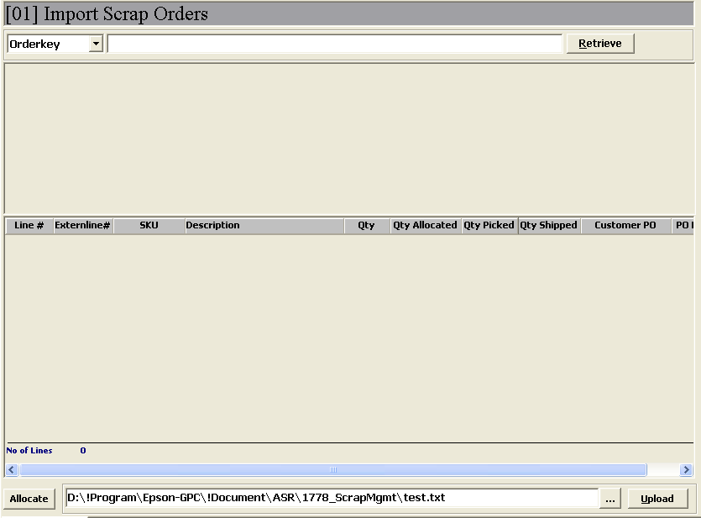
Step 1: Browse scrap item list in Text file format
Step 2:.
To upload scrap list for creating Orders and Allocate the Orders

- Click button <> to browse scrap list file in text (.txt) format.
.
Format as below:
SKU | AltSKU | ID | Loc | Qty | Allocated | Picked | InvoiceNo | CustPO | POLine | POQty | GENXP_Date | ROHS Tagged? | TP Tag
1000972 | 100097200 | L0116143 | SCRAP | 553 | 0 | 0 | GDNIEPP293968 | 4500031915 | 10 | 1000 | 14/09/2002
1000972 | 100097200 | L0439002 | SCRAP | 78 | 0 | 0 | GDN4ABB25446 | 4500076534 | 30 | 78 | 25/02/2005 |  | TP
1001275 | 100127500 | L0149547 | SCRAP | 15 | 0 | 0 | GDN2AAB99143 | 4500037431 | 60 | 17 | 30/12/2002
1001275 | 100127500 | L0427641 | SCRAP | 13 | 0 | 0 | GDN5ABB28506 | 4500079917 | 90 | 13 | 28/04/2005 |  | TP
1001275 | 100127500 | L0377260 | SCRAP | 8 | 0 | 0 | GDN4ABB21161 | 4500072443 | 180 | 8 | 09/12/2004
1001275 | 100127500 | L0382909 | SCRAP | 30 | 0 | 0 | GDN4ABB22656 | 4500072448 | 290 | 30 | 28/12/2004
1001303 | 100130300 | L0408760 | SCRAP | 3 | 0 | 0 | GDN5ABB28109 | 4500079917 | 100 | 3 | 21/04/2005 |  | TP
1001303 | 100130300 | L0439052 | SCRAP | 100 | 0 | 0 | GDN4AAB24584 | 4500076189 | 120 | 1741 | 16/02/2005 |  | TP
1001702 | 100170200 | l0438433 | SCRAP | 400 | 0 | 0 | GDN4AAB23865 | 4500075597 | 30 | 2350 | 27/01/2005 |  | TP

- Click button <>, to import scrap orders and system will allocate the orders according to listed LP# and qty.

- Upload summary will prompt as follow.

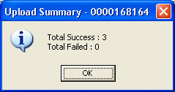

- System auto-allocation will proceed if order created successfully. 